4/5/22

Lewis Perdue
811 W. Napa St., Suite G, Sonoma,
CA 95476, USA

Dear Lewis,

Re: Bisphenol A (BPA) and BPA Conjugates Analysis Report
- Methods
  - Preparation of standards, quality control solutions and internal standards
Stock solutions of BPA and BPA monoglucuronide standards in methanol (1 mg/mL) were prepared and stored at -20 ºC until use. For the calibration curves, working solutions were prepared from the stock solutions of BPA and BPA monoglucuronide in acetonitrile/water (50:50; v/v) ranging from 0.5 – 512 ng/mL. The working solutions of the QC samples were also prepared in acetonitrile/water (50:50; v/v). Heavy isotope-labeled internal standards, namely d6-BPA and ¹³C₁₂-BPA monoglucuronide stock solutions (1 mg/mL) each were prepared by dissolving accurately weighed aliquots in methanol. Working solutions were prepared by diluting each internal standard stock solution to a final concentration of 250 ng/mL (d6-BPA) and 100 ng/mL (¹³C₁₂-BPA monoglucuronide) in acetonitrile/water (50:50; v/v).
  - Extraction of BPA and BPA conjugates from human serum
The extraction procedure reported by Wiraagni et al.¹ was modified and used for the extraction of BPA and conjugates from human serum. A 100 µL aliquot of blank human serum and 80 µL of internal standard mixture were placed in a 1.5 mL polypropylene micro-centrifuge tube, and standard solutions (20 µL) of varying concentrations of the BPA and BPA-monoglucuronide standards mixture were added (final concentrations of the calibration curve standards were 0.5, 1.5, 4, 8, 16, 32, 64, 128, 256 and 512 ng/mL). Acetonitrile containing 0.1% formic acid (800 µL) was added, and the mixture was vortexed for 2 min and allowed to stand in the freezer (-20 °C) to precipitate the proteins. After centrifugation at 18,000×g and 4 ºC for 30 min, the supernatant was transferred to a clean polypropylene micro-centrifuge tube, dried under vacuum at 30 °C, and reconstituted in 200 µL of the initial mobile phase (water/acetonitrile 1:1, v/v). Aliquots of 5 µL were analyzed using UHPLC-MS/MS. The same extraction procedure was applied in the determination of BPA contamination where solvent (acetonitrile:water 1:1 v/v) was used in place of serum.
The extraction of BPA and BPA monoglucuronide from the unknown human serum samples was carried out similarly. Briefly, human serum (0.1 mL) and 80 µL of internal standard mixture were added to a polypropylene micro-centrifuge tube. Aqueous acetonitrile (50% water, 20 µL) was added to make up the volume to 200 µL. Acetonitrile containing 0.1% formic acid (800 µL) was added, and the mixture was vortexed for 2 min and allowed to stand in the freezer (-20 °C) to precipitate the proteins. The sample work-up was carried out as described above for the standards.
Recovery of BPA and BPA-monoglucuronide
The method recovery was determined by comparing the peak areas obtained for acetonitrile extract samples spiked prior to extraction at LLOQ (0.5 ng/mL), low (5 ng/mL), medium (50 ng/mL) and high (500 ng/mL) concentrations with the peak areas obtained from spiked post-extraction samples. Similar extraction procedure as described above was applied.
  - Scale-up of extraction of BPA and BPA conjugates from human serum
For the analysis of BPA conjugates using a high resolution mass spectrometer, 500 µL of unknown human serum samples were added to a heavy wall glass vial. Internal standard solution (500 ng/mL final concentration) was added, and the mixture was extracted using 2 mL of acetonitrile containing 0.1% formic acid. The mixture was vortexed for 5 min and allowed to stand in the freezer (-20 °C) to precipitate the proteins. After centrifugation at 4000×g and 4 ºC for 30 min, the supernatant was transferred to a clean glass tube, dried under vacuum at 30 °C, and reconstituted in 100 µL of the initial mobile phase (water/acetonitrile 1:1, v/v). Aliquots of 10 µL were analyzed using UHPLC-MS/MS on Shimadzu 9030 high resolution Q-ToF mass spectrometer.
  - Instrumentation
Separation of BPA and conjugates was carried out using a Shimadzu (Kyoto, Japan) Nexera UHPLC system fitted with a Shim-pack XR ODS III (1.6 µm, 2.0 × 75 mm) column. The autosampler temperature was 15 °C, and the column oven was 40 °C. The BPA, BPA monoglucuronide and internal standards were eluted using a 3-min linear gradient from 20% to 90% acetonitrile in water containing 1 mM ammonium acetate, followed by 1-min hold at 90% acetonitrile. The column was re-equilibrated to 20% acetonitrile for 1.0 min before the next injection. The flow rate was 0.35 mL/min, and the injection volume was 5 µL.
The UHPLC system was interfaced with a Shimadzu LCMS-8050 triple quadruple mass spectrometer equipped with electrospray ionization (ESI). Negative ion ESI tandem mass spectrometric analysis was carried out with collision induced dissociation and selective reaction monitoring (SRM). Data acquisition, integration, and linear standard curves fitting were carried out using Shimadzu Lab Solutions software version 5.7.
High-resolution mass spectra of BPA conjugates were obtained on a Shimadzu 9030 Q-ToF-MS/MS equipped with a Nexera UHPLC system. The electrospray ionization interface temperature was 300 °C, and the voltage was -3.5 kV for negative ion mode. The heat block and desolvation line temperatures were 400 °C and 250 °C, respectively. Nitrogen was used as a drying gas at a flow rate of 10 L/min, for nebulization at 3 L/min and as a heating gas at 10 L/min. Mass spectra and product ion tandem mass spectra were acquired every 100 ms over the scan range of m/z 100 – 1000. Product ion tandem mass spectra were obtained using a collision energy of 35 V with an energy spread of 17 V.

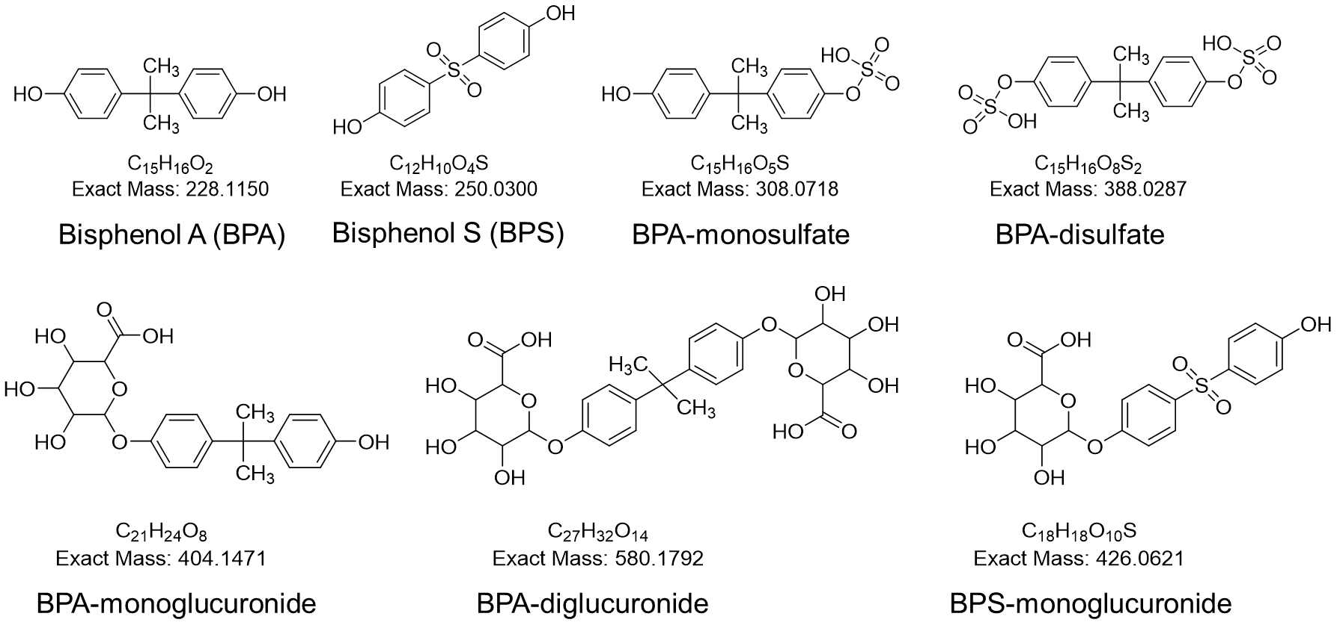
Figure 1. Bisphenol A and its conjugates

- Results

Table 1. Percent recovery of spiked BPA and BPA monoglucuronide standards in blank human serum. N = 3 technical replicates
QC | Concentration  (ng/mL) | % Recovery
 |  | BPA | BPA monoglucuronide
LLOQ | 0.50 | 90.1 | 120
Low | 5.0 | 86.1 | 112
Medium | 50 | 82.1 | 106
High | 500 | 102 | 104

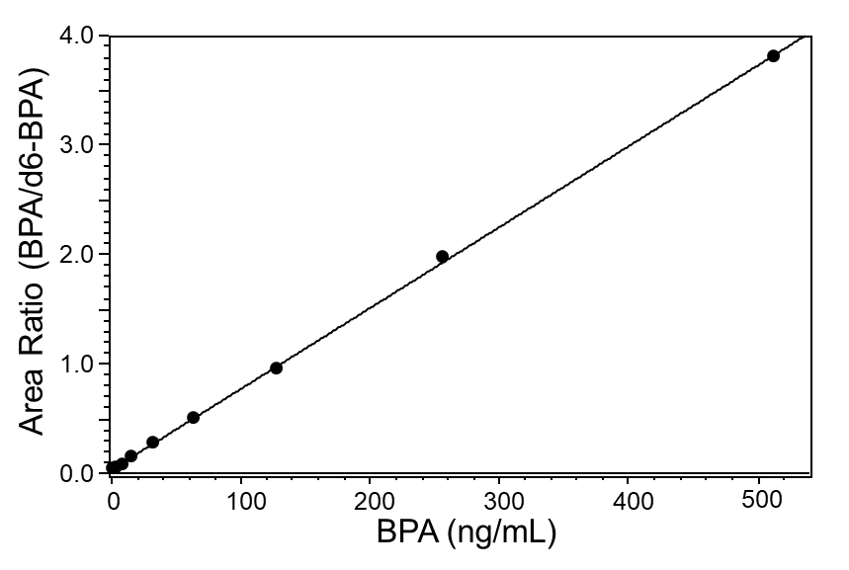
Figure 3: Standard curve of BPA spiked in blank human serum. The concentration ranged from 0.5 – 512 ng/mL. R² was >0.998. Each point of the curve was an average of 3 technical replicates and 2 analytical replicates.

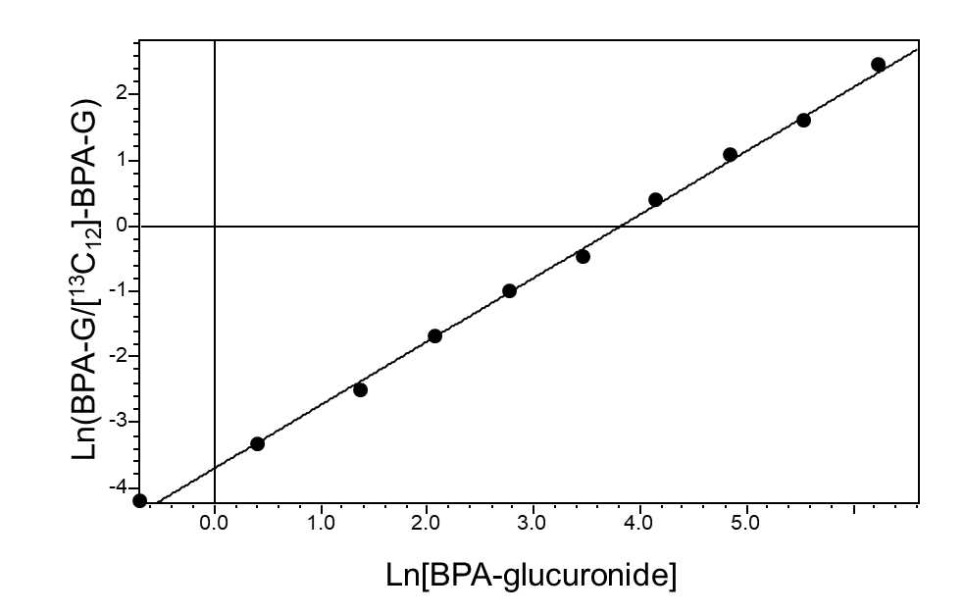

Figure 4: Standard curve of BPA monoglucuronide spiked in blank human serum. The concentration ranged from 0.5 – 512 ng/mL. R² was >0.998. Each point of the curve was an average of 3 technical replicates and 2 analytical replicates.

Table 2. Quantitative analysis of BPA and BPA monoglucuronide. N = 3 technical replicates
Unknown serum sample # | BPA (ng/mL) | BPA-monoglucuronide  (ng/mL)
1 | <LLOQ | <LLOQ
2 | <LLOQ | <LLOQ
3 | <LLOQ | <LLOQ

Table 3. High resolution mass of unknown human serum samples analyzed on 9030 Q-ToF
Analyte | High resolution m/z searched  [M – H]⁻ | Retention time (min)
¹³C₁₂-BPA-β-ᴅ-Glucuronide | 415.1790 | 5.7
d6-BPA | 233.1455 | 8.3
BPA Disulfate | 387.0286 | Not observed
BPA monoglucuronide | 403.1385 | 5.7
BPA diglucuronide | 579.1719 | Not observed
BPA monosulfate | 307.0645 | Not observed
BPS monoglucuronide | 425.0547 | Not observed

Reference
[1] Wiraagni, I. A.; Mohd, M. A.; bin Abd Rashid, R.; Haron, D. E. b. M. Validation of a simple extraction procedure for bisphenol A identification from human plasma. PloS One 2019, 14, e0221774.

